Day 17 Revisit

Completed Week3 QC in the morning Time.

HTML – HyperText Markup Language.

Who is the father of HTML? – Tim Berners Lee (1993) WWW & HTML

WWW – World Wide Web

Networking – To share the data & resources.

Network – Connecting two or more electronic devices [particularly pc’s/laptops/desktops] using wired or wireless method.

Each computer will have an ip address.

IP Address = Internet Protocol Address.

Your PC/Laptop will have many ports USB ports, HDMI Port, VGA Port, SD Card Reader port, Thunder bold port, Ethernet Port (Physical ports) – You can connect with external devices like monitors, printers, scanners, etc.,

Humans will have some physical address like home address, office address, school or college address.

Each computer/device connected to network will have a virtual address. This address is called as IP address.

Physical Address

Apt/Building No, Street Name,

Area,

City

State

Zip code

Country

IP Address – ipv4 & ipv6 – Number based address

193.65.122.45 – Example of IPv4 Address

[0-255].[0-255].[0-255].[0-255]

Internet – Is Network of Networks

Types of Networks [ LAN – Local Area Network, MAN – Metropolitan Area Network, WAN – Wide Area Network]

Internet – Connecting all type of Networks together.

Each resource connected with internet will have an Address called IP address.

Each device will have an address to indicate itself. Localhost : 127.0.0.1

Servers (Client – Server Concept)

1. Web Servers (Helpful to Servlets, JSP, ASP etc) [Tomcat, IIS]
2. Application Servers [ EJB, MQ, JMS, JNDI – J2EE features] [Glassfish, Weblogic, IBM WebSphere]
3. Database Servers [ These will be useful for managing the data in a structured format]

Client & Server Concept uses Request & Response Model

1. Client will send request (Request object)
2. Server will respond for each valid request by executing some code in the server side.

For both Request & Response http is used for communication.

http – hypertext transfer protocol.

What is protocol – It’s a set of rules to be followed while communicating between electronic devices.

Popular protocols

1. http = hypertext transfer protocol (stateless)
2. https = hypertext transfer protocol secured
3. ftp = file transfer protocol
4. smtp = simple mail transfer protocol
5. pop = post office protocol

HTML – It’s very user friendly language.

HTML is very easy to learn. Is not case and space sensitive.

Tags are pre-defined. Most of the tags in html will have a closing tag.

<html> - Is the root tag for HTML document.

Html file will have an extension .html or .htm

Any text editor can be used to create html files.

HTML will not throw any compile time/ run time error. Even if you make some mistakes, it’ll try to ignore it and process the rest of the document.

<html> - Opening HTML tag

</HTML> -- Closing html Tag

Html pages are called as web pages or web sites.

Using HTML, we can create static web pages/ web sites.

Popular IDE to create HTML pages are

1. VS Code (Visual Studio Code – developed by Microsoft)
2. ATOM
3. Sublime
4. Brackets
5. Notepad ++
6. WordPad

Each HTML page will have two sections called head & body.

<html> -- root tag or parent tag

<head> -- child1 tag

</head>

<body> --- child2 tag

<p> </p> -- Grant child tags

<table> </table>

</body>

</html>

Child1 & child2 are sibling tags (they belongs to same parent)

Web Page vs Web Site

* Web Page represents a single page in a web-site (login page, forgot password page, about-us page, contact-us page, price page, update profile page)
* Web Site represents group of pages which are connected together serving for a single company/ entity/ person/ object. [amazon.com, facebook.com, google.com]

What is mean by elements in HTML?

1. Combination of Tags along with its content. <p> This is first para. </p>
2. Element will consist of opening tag, closing tag and content in between.

What is mean by attributes in HTML?

1. Attributes will be added to opening tags to provide more information for that particular html element.
2. Some important attributes are name, value, disabled, id, class, max, min, required, placeholder

HTML will convert multiple spaces to a single space. HTML is not space sensitive as well.

What is the tag name used for text animation or scrolling/rolling text.??

<marquee> tag

<https://www.tutorialspoint.com/html/html_marquees.htm>

<https://www.w3schools.in/html/marquee-tag>

The <marquee> tag is a container tag of HTML is implemented for creating scrollable text or images within a web page from either left to right or vice versa, or top to bottom or vice versa. But this tag has been **deprecated in the new version of HTML, i.e., HTML 5**.

The different attributes of <marquee> tag are:

|  |  |
| --- | --- |
| Attribute | Description |
| width | provides the width or breadth of a marquee. For example width="10" or width="20%" |
| height | provides the height or length of a marquee. For example height="20" or height="30%" |
| direction | provides the direction or way in which your marquee will allow you to scroll. The value of this attribute can be: left, right, up or down |
| scrolldelay | provides a feature whose value will be used for delaying among each jump. |
| scrollamount | provides value for speeding the marquee feature |
| behavior | provides the scrolling type in a marquee. That scrolling can be like sliding, scrolling or alternate |
| loop | provides how many times the marquee will loop |
| bgcolor | provides a background color where the value will be either the name of the color or the hexadecimal color-code. |
| vspace | provides a vertical space and its value can be like: vspace="20" or vspace="30%" |
| hspace | provides a horizontal space and its value can be like: vspace="20" or vspace="30%" |

Table

To align the data in a proper format.

Tags related to table

1. <table> </table> = Root tag for table
2. <tr> </tr> = table row
3. <td> </td> = table data
4. <thead></thead> = table heading
5. <tbody> </tbody> = table body

DTD = Document Type Declaration/Definition

XSD = XML Schema Definition/Declaration

CSS = Cascading Style Sheet.

UTF-8 == Unicode Text Format (8 bit)

HTML is processed by DOM

DOM stands for Document Object Model – For each web page, the browser will create a tree like data structure to organize the data. DOM will have a single root (called html) and two branches (namely head & body)

All other html tags/elements will go inside these two branches only.

Self – closing Tags – Example <br/>, <hr/> <input />

Inline Elements (span) – This will not occupy entire line

Block Elements (div) – This will occupy the entire line

<form> This tag used to get input from user and pass it to another page.

Imp attribute in form tag is “action” which specifies the location where the data needs to be submitted.

Input types

1. Text
2. Button (submit/reset)
3. Password
4. Email
5. Number
6. File
7. Hidden
8. Date
9. DateTime
10. URL
11. Radio
12. Select

Newly added tags in HTML5

1. Audio
2. Video
3. Header
4. Footer
5. Aside
6. GeoTags
7. Media Query

While submitting form data, the default submission method is “GET”

Get is faster but display all the data in URL itself. It not secured for sensitive information like password, debit/credit card number/ssn

Another method used for submitting the data securely is “POST” method

“POST” method will add the content in the body of the request object.

All the Browsers are web clients. They can able to send the Request object to the server.

Both Client & Server can be in the same machine.

Google Chrome, Mozilla Firefox, Apple Safari, Opera, == Popular Browsers (Web clients)

Apache Tomcat, IIS, Weblogic, GlassFish – Popular Servers

Types of Client & Server Architecture

1. Fat Client Thin Server (UI & Business Logic in Client side) [2-tier]
2. Thin Client Fat Server (DB & Business Logic in Server Side) [2-tier]
3. 3 tier [Presentation tier (View Layer/UI Layer, front end layer), Data tier (DBMS/Model layer), Business Logic tier (Backend layer/application layer/ Controller )

Types of Web Sites or Web Pages

1. Static Web Sites/Page/Application – It will not change with respect to time or user. (Webpages of Temples, mosque, churches)
2. Dynamic Web Site/Page/Application – It will change with respect to the user and time. (GMAIL, LINKEDIN, FACEBOOK, TWITTER)

HTML is used to create Static Web pages/ Web Sites only

HTML5, client side validations can be done to a little extend.

* We can check if the email format is correct or not
* We can check the phone number length is correct or not
* We can check that the username field is empty or not
* We can check that the password consist of minimum 8 characters, alpha numeric combination with atleast one number and one special symbol.

Every Browser will have the following 3 engines

1. HTML Rendering Engine (Responsible for generating the UI – User Interface)
2. JavaScript Engine (Responsible to run the JavaScript code)
3. Styling/CSS Engine (Responsible to improve the appearance of the page & generate proper look and feel)

Browser can directly understand (Client Side Coding)

1. Html files
2. Css files
3. JavaScript files

Browser can’t handle Java/Python/php/.Net code directly

Web Servers are used to overcome this challenge

Apache Tomcat (Open Source Web Server) developed by Apache Software Foundation

Tomcat is also called as Servlet Container or Web Server.

Creating Web Based Application (Dynamic Web Application) using Eclipse EE

1. Open Eclipse
2. File 🡪 New 🡪Other 🡪 Search for web 🡪 Dynamic Web Application

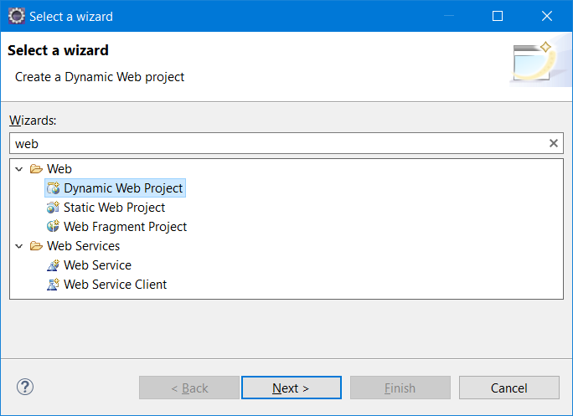

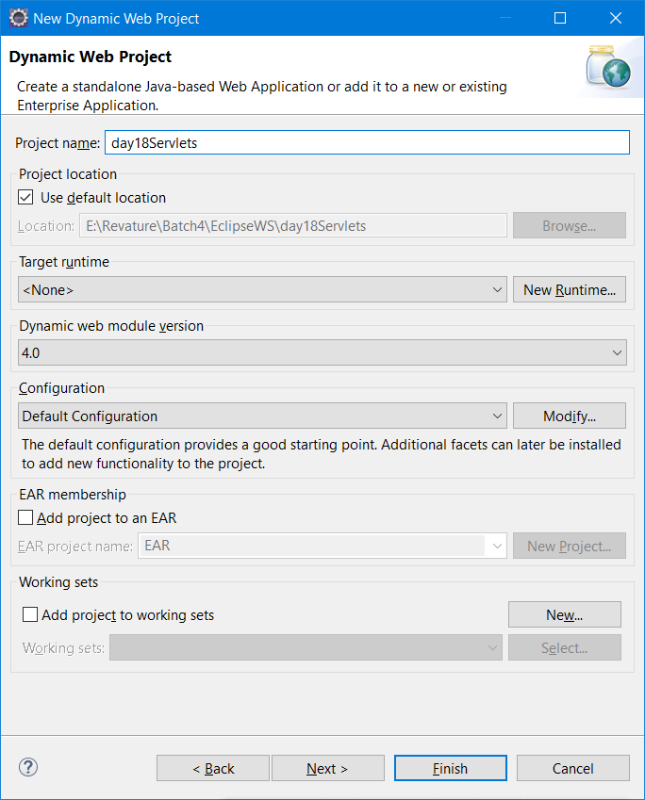

Click on “New Runtime” button

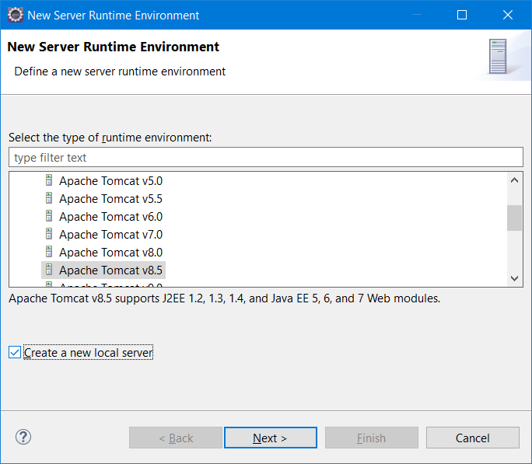

Make sure to select the proper tomcat version, click on “Create a New Local Server” checkbox.

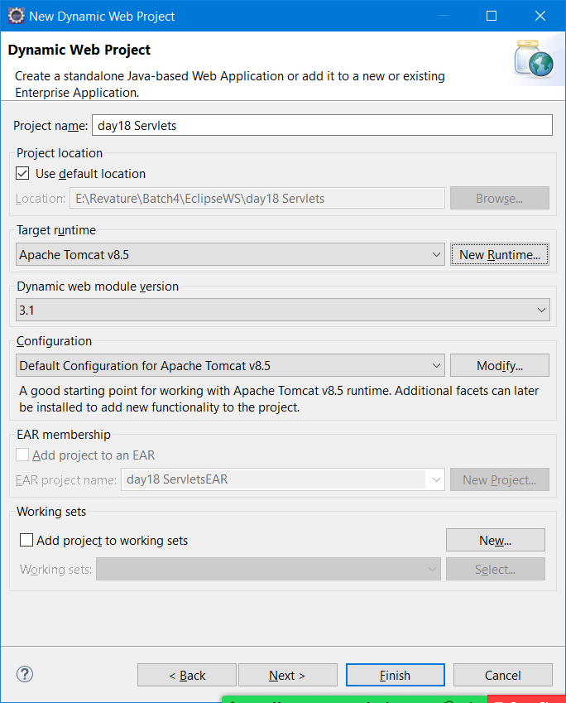

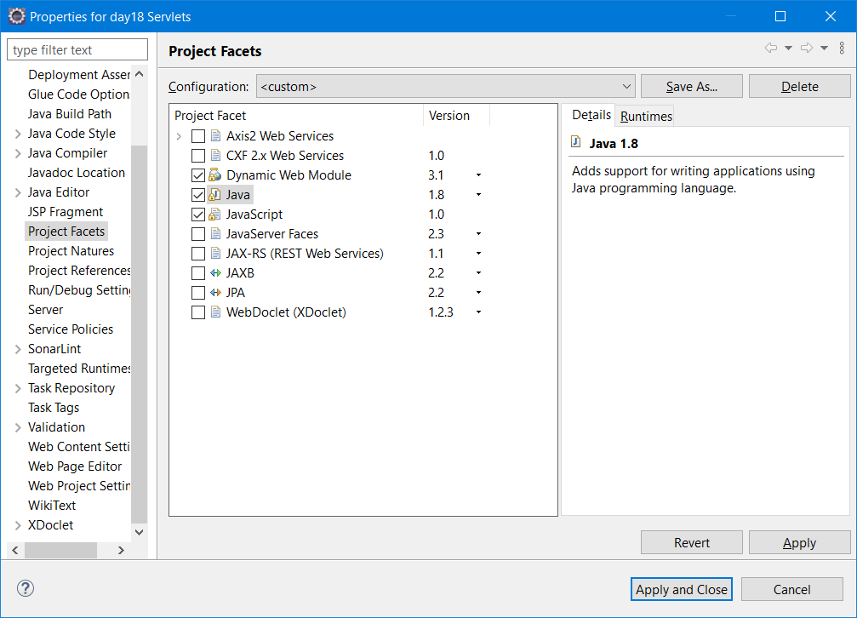

Each dynamic Web Project application will have web.xml (Optional now days)

Web.xml is also called as Deployment Descriptor.

Web.xml is the Entry point of Dynamic Web Project

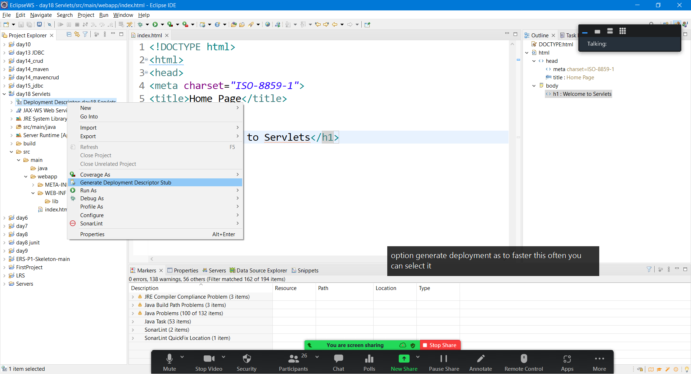

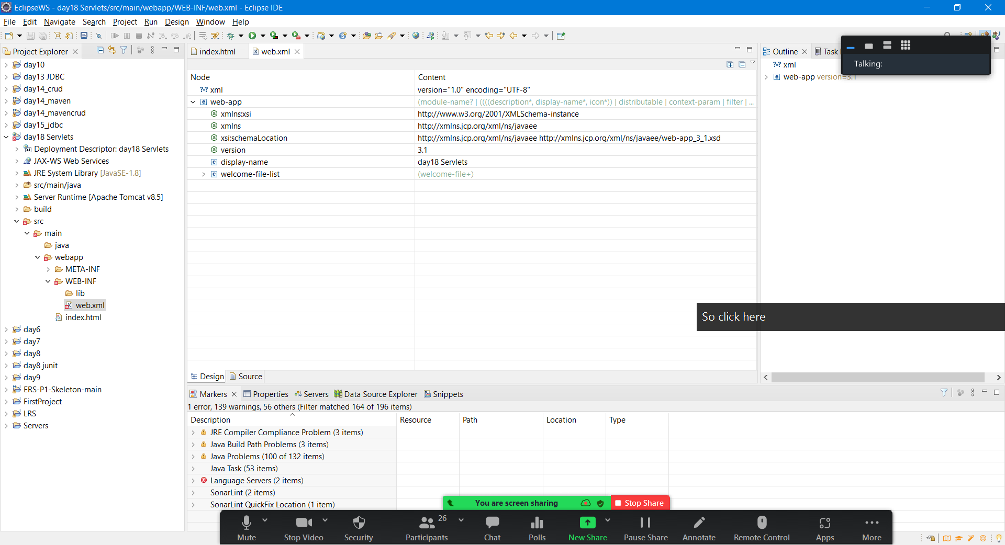

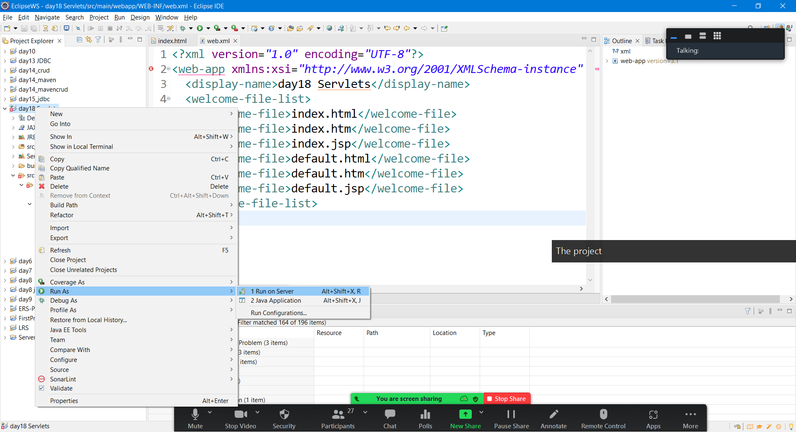

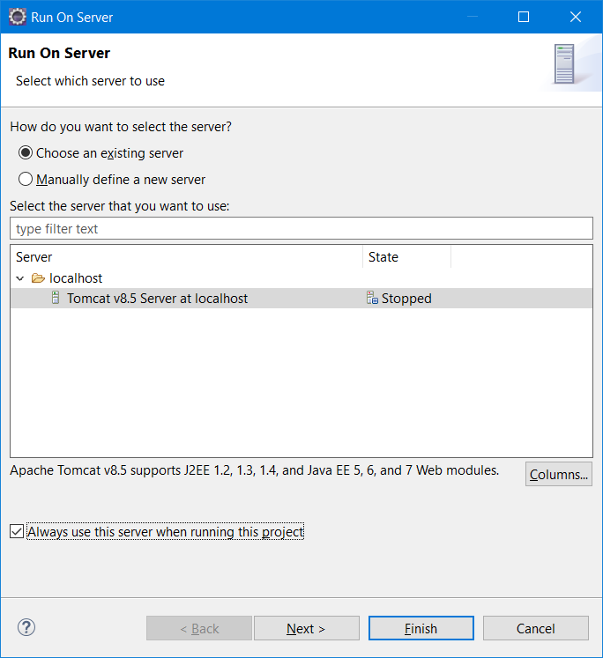

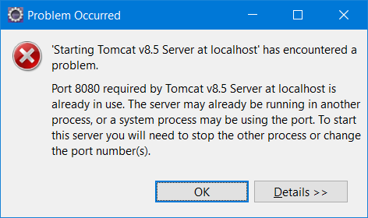

Double click the server in Servers tab

Servlet is a Java Class which can be executed inside servers only.

Types of Servlet

1. Generic Servlet (Used for all protocol- http/ftp/smtp/pop)
2. HttpServlet (Used only for Http)

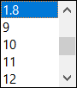

<http://localhost:8085/day18_Servlets/> == Context path or context root

Servlet = HTML code is embedded inside Java code

JSP = Java Server Pages ( Java code written directly inside HTML)

Servlet Life Cycle Methods

1. Init()
2. Service()
3. Destroy()